africa.vs.others

roqeeb

2024-08-17

## Load Required Libraries  
library(tidyverse)

## ── Attaching core tidyverse packages ──────────────────────── tidyverse 2.0.0 ──  
## ✔ dplyr 1.1.4 ✔ readr 2.1.5  
## ✔ forcats 1.0.0 ✔ stringr 1.5.1  
## ✔ ggplot2 3.5.1 ✔ tibble 3.2.1  
## ✔ lubridate 1.9.3 ✔ tidyr 1.3.1  
## ✔ purrr 1.0.2   
## ── Conflicts ────────────────────────────────────────── tidyverse_conflicts() ──  
## ✖ dplyr::filter() masks stats::filter()  
## ✖ dplyr::lag() masks stats::lag()  
## ℹ Use the conflicted package (<http://conflicted.r-lib.org/>) to force all conflicts to become errors

library(readxl)  
library(janitor)

##   
## Attaching package: 'janitor'  
##   
## The following objects are masked from 'package:stats':  
##   
## chisq.test, fisher.test

## Load the Data  
# Read in the data from the working directory  
df <- read_excel("africa.vs.world.xlsx")  
  
  
df <- clean_names(df)  
df <- df %>% filter(!is.na(status))  
  
### Converting to Factor  
  
df <- df %>%  
 mutate( goup = as.factor(group),  
 status = as.factor(status),  
 concentration = as.numeric(concentration),  
 antibiotics = as.factor(antibiotics),  
 species = as.factor(species)  
 )  
  
## Summary of the Data  
  
summary(df)

## group species status   
## Length:530034 Escherichia coli : 92950 Intermediate: 36752   
## Class :character Klebsiella pneumoniae : 85695 Resistant :115551   
## Mode :character Staphylococcus aureus : 73552 Susceptible :377731   
## Pseudomonas aeruginosa : 50033   
## Enterobacter cloacae : 26582   
## Streptococcus pneumoniae: 21737   
## (Other) :179485   
## antibiotics concentration goup   
## Levofloxacin : 42031 Min. : 0.002 Africa:330100   
## Tigecycline : 34637 1st Qu.: 0.120 Others:199934   
## Meropenem : 29635 Median : 1.000   
## Piperacillin tazobactam: 27605 Mean : 7.000   
## Cefepime : 26786 3rd Qu.: 4.000   
## Amikacin : 26114 Max. :256.000   
## (Other) :343226

## Visualizing the Data

### Distrubution of status across countries

ggplot(df, aes(x = group, fill = status)) +  
 geom_bar(position = "fill") +  
 labs(title = "Proportion of Resistance Status by Group", x = "Group", y = "Proportion") +  
 scale_fill_manual(values =c("Intermediate"="skyblue","Resistant"="red","Susceptible"="green")) +  
 theme_bw() +  
 coord_flip()

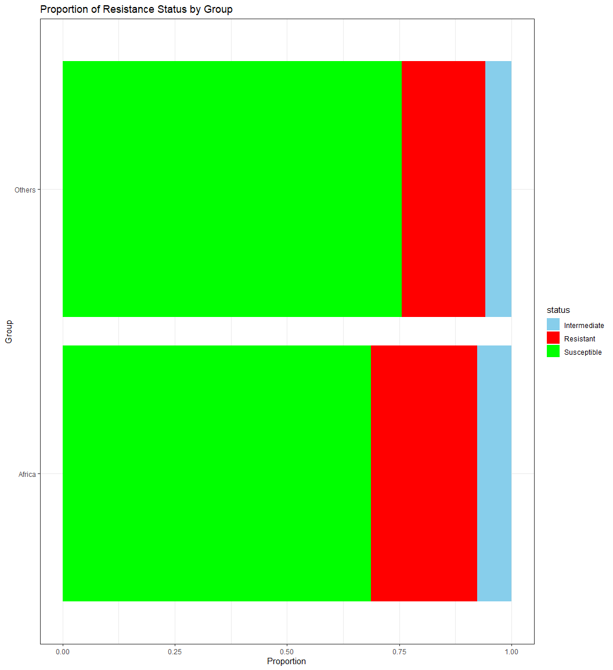

ggplot(df, aes(x = antibiotics, fill = status)) +  
 geom_bar(position = "fill") +  
 facet_grid( ~ group, scales = "free") +  
 labs(title = "Panel of Resistance Status by Antibiotics", x = "Antibiotics", y = "Proportion") +  
 scale_fill_manual(values =c("Intermediate"="skyblue","Resistant"="red","Susceptible"="green")) +  
 theme_bw() +  
 coord_flip()

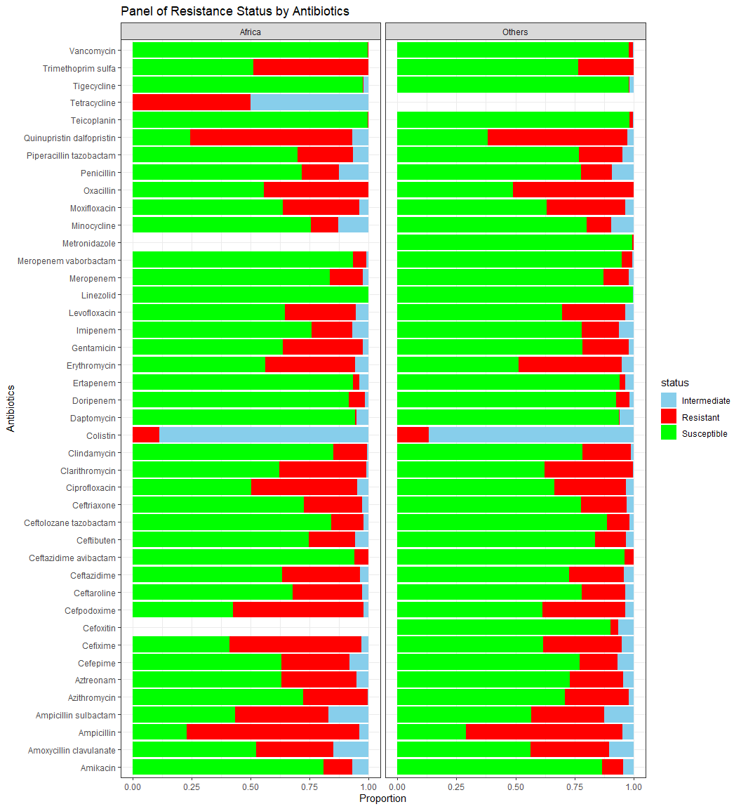

ggplot(df, aes(x = status, y = concentration, fill = status))+  
 geom_boxplot()+  
 facet_grid(~ group, scales ="free")+  
 labs(  
 title ="Comparison of MIC by Status for Each Group",  
 x ="Status",  
 y ="MIC (Minimum Inhibitory Concentration)")+  
 theme_bw()

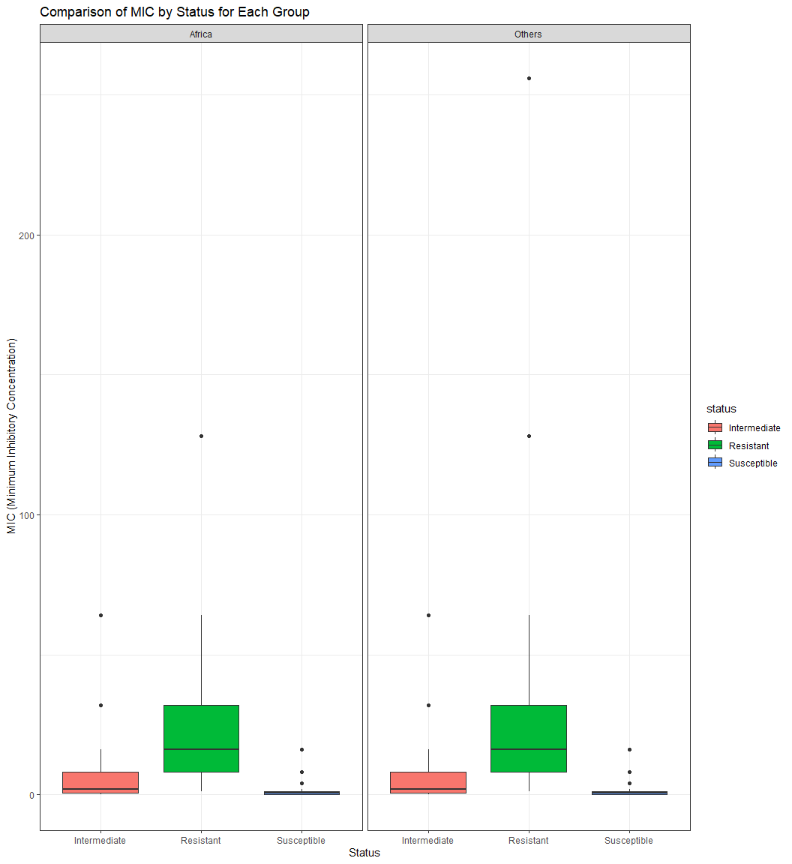

ggplot(df, aes(x = group, y = concentration, fill = status))+  
 geom_boxplot()+  
 facet_wrap(~ antibiotics, scales ="free")+  
 labs(  
 title ="Comparison of MIC by Status for Each Group",  
 x ="Status",  
 y ="MIC (Minimum Inhibitory Concentration)")+  
 theme_bw()

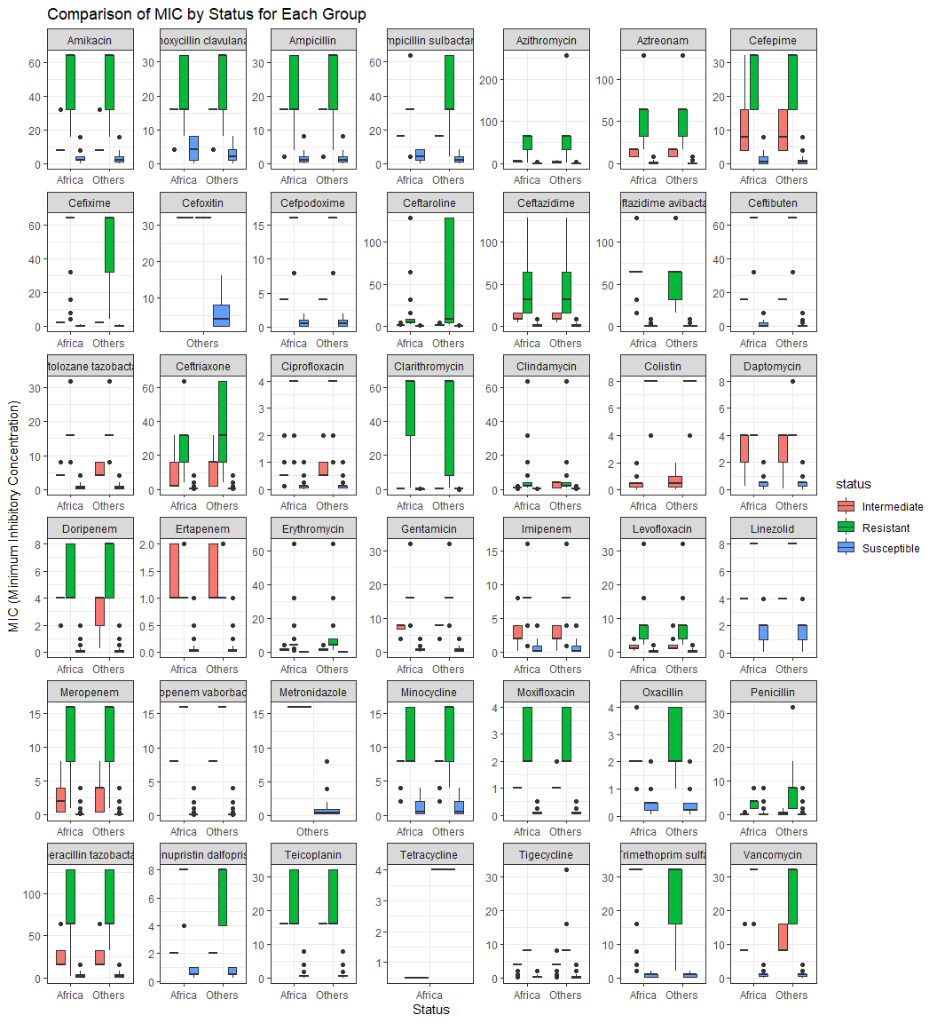

# inferences

## Simple ANOVA for MIC by Group (Africa vs. the World), controlling for antibiotics, species

model <- lm(concentration ~ group + antibiotics + species, data = df)  
summary(model)

##   
## Call:  
## lm(formula = concentration ~ group + antibiotics + species, data = df)  
##   
## Residuals:  
## Min 1Q Median 3Q Max   
## -36.989 -5.693 -1.107 1.713 240.467   
##   
## Coefficients:  
## Estimate Std. Error t value  
## (Intercept) 8.70211 15.01496 0.580  
## groupOthers -0.70211 0.04345 -16.159  
## antibioticsAmoxycillin clavulanate 5.91682 0.14116 41.917  
## antibioticsAmpicillin 12.59224 0.13859 90.860  
## antibioticsAmpicillin sulbactam 10.80547 0.17946 60.212  
## antibioticsAzithromycin 13.77985 0.48625 28.339  
## antibioticsAztreonam 11.29526 0.15259 74.026  
## antibioticsCefepime -0.01015 0.13066 -0.078  
## antibioticsCefixime 20.02726 0.40126 49.911  
## antibioticsCefoxitin 8.02343 1.36014 5.899  
## antibioticsCefpodoxime 1.26616 0.39873 3.176  
## antibioticsCeftaroline 3.32626 0.14616 22.758  
## antibioticsCeftazidime 8.55758 0.13419 63.774  
## antibioticsCeftazidime avibactam -2.80401 0.15266 -18.367  
## antibioticsCeftibuten 5.60804 0.40428 13.872  
## antibioticsCeftolozane tazobactam -4.56696 0.19313 -23.647  
## antibioticsCeftriaxone 2.32427 0.16219 14.331  
## antibioticsCiprofloxacin -7.12399 0.16639 -42.815  
## antibioticsClarithromycin 14.21752 0.57041 24.925  
## antibioticsClindamycin -0.76506 0.19244 -3.976  
## antibioticsColistin -7.03342 0.15143 -46.446  
## antibioticsDaptomycin -1.84698 0.20314 -9.092  
## antibioticsDoripenem -5.73047 0.20606 -27.809  
## antibioticsErtapenem -5.24020 0.40390 -12.974  
## antibioticsErythromycin 0.54855 0.18726 2.929  
## antibioticsGentamicin -0.68524 0.15793 -4.339  
## antibioticsImipenem -6.27605 0.14315 -43.842  
## antibioticsLevofloxacin -3.58307 0.12118 -29.569  
## antibioticsLinezolid -0.92422 0.17206 -5.371  
## antibioticsMeropenem -5.43910 0.12817 -42.435  
## antibioticsMeropenem vaborbactam -5.88514 0.22791 -25.822  
## antibioticsMetronidazole -0.32642 0.94404 -0.346  
## antibioticsMinocycline -2.04424 0.15685 -13.033  
## antibioticsMoxifloxacin -1.40366 0.27578 -5.090  
## antibioticsOxacillin -1.03806 0.22213 -4.673  
## antibioticsPenicillin -1.06745 0.25208 -4.235  
## antibioticsPiperacillin tazobactam 13.53758 0.12990 104.216  
## antibioticsQuinupristin dalfopristin 1.19622 1.11859 1.069  
## antibioticsTeicoplanin -1.32859 0.20793 -6.390  
## antibioticsTetracycline 6.98421 11.40533 0.612  
## antibioticsTigecycline -4.18895 0.12805 -32.714  
## antibioticsTrimethoprim sulfa 4.45792 0.15764 28.280  
## antibioticsVancomycin -1.30131 0.17192 -7.569  
## speciesAcinetobacter anitratus -8.96101 16.44834 -0.545  
## speciesAcinetobacter baumannii 14.80931 15.01553 0.986  
## speciesAcinetobacter baylyi -6.73724 15.11493 -0.446  
## speciesAcinetobacter beijerinckii -2.05444 16.21812 -0.127  
## speciesAcinetobacter bereziniae -3.02282 15.04257 -0.201  
## speciesAcinetobacter calcoaceticus -4.78441 15.07466 -0.317  
## speciesAcinetobacter colistiniresistens -7.43857 15.62832 -0.476  
## speciesAcinetobacter courvalinii 9.34102 15.47728 0.604  
## speciesAcinetobacter dijkshoorniae -5.01762 15.03792 -0.334  
## speciesAcinetobacter dispersus -10.90274 18.38964 -0.593  
## speciesAcinetobacter guillouiae -5.17499 15.11364 -0.342  
## speciesAcinetobacter haemolyticus -2.09703 15.04371 -0.139  
## speciesAcinetobacter johnsonii -5.94270 15.08516 -0.394  
## speciesAcinetobacter junii -5.25266 15.04654 -0.349  
## speciesAcinetobacter lactucae -3.84434 15.13579 -0.254  
## speciesAcinetobacter lwoffii -4.87680 15.03311 -0.324  
## speciesAcinetobacter nosocomialis -1.86759 15.02137 -0.124  
## speciesAcinetobacter parvus -8.13135 15.62831 -0.520  
## speciesAcinetobacter pitii -4.05809 15.02282 -0.270  
## speciesAcinetobacter proteolyticus -3.97641 15.54221 -0.256  
## speciesAcinetobacter pseudolwoffii -1.65845 18.38984 -0.090  
## speciesAcinetobacter radioresistens -7.89604 15.05507 -0.524  
## speciesAcinetobacter schindleri -3.97134 15.15889 -0.262  
## speciesAcinetobacter seifertii -4.57848 15.10874 -0.303  
## speciesAcinetobacter soli -7.14742 15.24100 -0.469  
## speciesAcinetobacter spp 9.80606 15.01951 0.653  
## speciesAcinetobacter tjernbergiae -9.13581 17.33788 -0.527  
## speciesAcinetobacter towneri -21.41758 21.23467 -1.009  
## speciesAcinetobacter ursingii -2.15325 15.03672 -0.143  
## speciesAcinetobacter variabilis 2.24973 15.33812 0.147  
## speciesAcinetobacter venetianus -1.22395 21.23476 -0.058  
## speciesAcinetobacter vivianii -1.22395 21.23476 -0.058  
## speciesAcinetobacter, non-speciated 11.81820 15.03978 0.786  
## speciesAeromonas hydrophila -7.58243 15.74807 -0.481  
## speciesAeromonas veronii -6.35071 15.92601 -0.399  
## speciesAlcaligenes faecalis 0.35357 15.74807 0.022  
## speciesAnaerococcus prevotii -8.09406 15.22851 -0.532  
## speciesAnaerococcus tetradius -2.50090 18.38987 -0.136  
## speciesAnaerococcus vaginalis -7.55761 16.78752 -0.450  
## speciesBacteroides caccae -5.30366 15.68340 -0.338  
## speciesBacteroides capsillosis -3.67358 21.25525 -0.173  
## speciesBacteroides cellulosilyticus -12.02343 21.27779 -0.565  
## speciesBacteroides eggerthii -8.35402 17.34394 -0.482  
## speciesBacteroides fragilis -6.82706 15.03684 -0.454  
## speciesBacteroides intestinalis -3.61731 18.39574 -0.197  
## speciesBacteroides merdeae -0.56090 21.23466 -0.026  
## speciesBacteroides nordii -14.77003 17.33816 -0.852  
## speciesBacteroides ovatus -4.81586 15.17397 -0.317  
## speciesBacteroides pyogenes -7.96860 16.22133 -0.491  
## speciesBacteroides spp -6.98494 18.39043 -0.380  
## speciesBacteroides stercosis -6.44453 15.93425 -0.404  
## speciesBacteroides thetaiotaomicron -2.60839 15.11380 -0.173  
## speciesBacteroides uniformis -6.75992 15.35811 -0.440  
## speciesBacteroides vulgatus -6.88106 15.17569 -0.453  
## speciesBordetella spp -2.50090 21.23466 -0.118  
## speciesBordetella trematum 1.60957 15.74807 0.102  
## speciesBurkholderia cenocepacia -6.20045 16.78756 -0.369  
## speciesCampylobacter ureolyticus -2.50090 21.23466 -0.118  
## speciesCitrobacter amalonaticus -5.71556 15.04754 -0.380  
## speciesCitrobacter braakii -4.03502 15.03337 -0.268  
## speciesCitrobacter diversus 2.25916 18.38982 0.123  
## speciesCitrobacter farmeri 3.32280 15.23441 0.218  
## speciesCitrobacter freundii -1.56709 15.01669 -0.104  
## speciesCitrobacter gillenii -9.15325 16.21827 -0.564  
## speciesCitrobacter koseri -7.13953 15.01697 -0.475  
## speciesCitrobacter murliniae -5.31400 15.74808 -0.337  
## speciesCitrobacter sedlakii -0.26853 15.07115 -0.018  
## speciesCitrobacter spp -3.07784 15.04230 -0.205  
## speciesCitrobacter youngae -0.97618 17.33813 -0.056  
## speciesCitrobacter, non-speciated -0.86177 15.20647 -0.057  
## speciesClostridioides difficile -5.62693 15.03469 -0.374  
## speciesClostridium barati -12.48932 18.38977 -0.679  
## speciesClostridium beijerinckii -21.47758 21.23467 -1.011  
## speciesClostridium bolteae -3.75105 21.23466 -0.177  
## speciesClostridium butyricum -5.85812 15.68318 -0.374  
## speciesClostridium cadaveris -14.29558 18.39574 -0.777  
## speciesClostridium celerecrescens -2.99224 18.39573 -0.163  
## speciesClostridium citroniae -0.56090 21.23466 -0.026  
## speciesClostridium clostridiiformis 0.06796 15.68318 0.004  
## speciesClostridium glycolicum -6.67358 21.25525 -0.314  
## speciesClostridium hathewayi -3.84520 16.05254 -0.240  
## speciesClostridium histolyticum 1.43910 21.23466 0.068  
## speciesClostridium innocuum -7.41790 15.32514 -0.484  
## speciesClostridium paraputrificum -8.89910 15.62928 -0.569  
## speciesClostridium perfringens -7.71072 15.06529 -0.512  
## speciesClostridium ramosum -5.85624 15.58236 -0.376  
## speciesClostridium septicum -8.96738 15.92652 -0.563  
## speciesClostridium sordellii -7.09115 17.34125 -0.409  
## speciesClostridium sphenoides -7.55358 21.25525 -0.355  
## speciesClostridium sporogenes -9.98046 15.47841 -0.645  
## speciesClostridium spp -5.46709 15.82894 -0.345  
## speciesClostridium subterminale -6.98494 21.23515 -0.329  
## speciesClostridium tertium -4.52617 15.92678 -0.284  
## speciesCronobacter spp -4.67396 18.38980 -0.254  
## speciesEggerthella lenta -5.93255 21.23577 -0.279  
## speciesElizabethkingia anophelis 24.01015 21.23468 1.131  
## speciesEnterobacter agglomerans -1.63193 15.05707 -0.108  
## speciesEnterobacter asburiae -3.29537 15.01952 -0.219  
## speciesEnterobacter bugandensis -5.11544 15.02148 -0.341  
## speciesEnterobacter cancerogenus -5.86287 16.05184 -0.365  
## speciesEnterobacter cloacae 0.40899 15.01547 0.027  
## speciesEnterobacter gergoviae -13.56692 18.38981 -0.738  
## speciesEnterobacter hormaechi -0.44262 15.02059 -0.029  
## speciesEnterobacter intermedium -3.80399 18.38976 -0.207  
## speciesEnterobacter kobei -4.60886 15.02736 -0.307  
## speciesEnterobacter ludwigii -4.07761 15.07607 -0.270  
## speciesEnterobacter roggenkampii -3.26154 15.06153 -0.217  
## speciesEnterobacter sakazakii -2.06083 15.14633 -0.136  
## speciesEnterobacter spp -2.99464 15.01696 -0.199  
## speciesEnterobacter taylorae -3.31105 21.23466 -0.156  
## speciesEnterobacter xiangfangensis -3.35305 15.03243 -0.223  
## speciesEnterobacter, non-speciated -2.12316 15.03089 -0.141  
## speciesEnterocloster bolteae 25.06745 21.23577 1.180  
## speciesEnterocloster clostridioformis -0.56090 21.23466 -0.026  
## speciesEnterococcus avium -6.63514 15.13406 -0.438  
## speciesEnterococcus canintestini -7.40932 15.92619 -0.465  
## speciesEnterococcus casseliflavus -3.39247 15.15635 -0.224  
## speciesEnterococcus durans -3.65752 15.27207 -0.239  
## speciesEnterococcus faecalis -5.99913 15.01594 -0.400  
## speciesEnterococcus faecium -2.95860 15.01679 -0.197  
## speciesEnterococcus flavescens 1.06745 21.23577 0.050  
## speciesEnterococcus gallinarum -2.23421 15.19736 -0.147  
## speciesEnterococcus Group D 4.46144 16.78763 0.266  
## speciesEnterococcus hirae -6.78140 15.24117 -0.445  
## speciesEnterococcus malodoratus -12.59224 21.23473 -0.593  
## speciesEnterococcus raffinosus -4.34247 15.33832 -0.283  
## speciesEnterococcus spp -7.02362 15.11515 -0.465  
## speciesEnterococcus, non-speciated -5.33260 15.13407 -0.352  
## speciesEscherichia coli -3.17074 15.01528 -0.211  
## speciesEscherichia hermanii -7.61215 15.50765 -0.491  
## speciesEscherichia spp -8.23557 15.31259 -0.538  
## speciesFinegoldia magna -8.59808 15.14528 -0.568  
## speciesHaemophilus influenzae -10.77612 15.01584 -0.718  
## speciesHaemophilus parahaemolyticus -8.88687 18.38978 -0.483  
## speciesHaemophilus parainfluenzae -10.41683 15.04175 -0.693  
## speciesHaemophilus spp -8.55394 18.38979 -0.465  
## speciesHafnia alvei -6.97941 18.38982 -0.380  
## speciesKlebsiella aerogenes -2.33533 15.01616 -0.156  
## speciesKlebsiella ornithinolytica -10.26427 21.23489 -0.483  
## speciesKlebsiella oxytoca -5.36442 15.01597 -0.357  
## speciesKlebsiella ozaenae -7.69024 15.30122 -0.503  
## speciesKlebsiella planticola 14.95123 15.45052 0.968  
## speciesKlebsiella pneumoniae 1.89423 15.01529 0.126  
## speciesKlebsiella spp -0.18929 15.03642 -0.013  
## speciesKlebsiella variicola -7.17725 15.01809 -0.478  
## speciesKlebsiella, non-speciated 2.90050 15.13978 0.192  
## speciesKluyvera ascorbata -10.82626 21.23478 -0.510  
## speciesLelliottia amnigena -0.54906 15.25539 -0.036  
## speciesMorganella morganii -4.27188 15.01654 -0.284  
## speciesMyroides odoratimimus 20.72857 15.74807 1.316  
## speciesNeisseria gonorrhoeae -13.43632 15.58222 -0.862  
## speciesPantoea agglomerans -14.33116 17.33809 -0.827  
## speciesPantoea dispersa 12.70538 15.42667 0.824  
## speciesParabacteroides distasonis -5.55013 15.24925 -0.364  
## speciesParabacteroides goldsteinii 0.76506 21.23515 0.036  
## speciesParvimonas micra -7.98270 15.11431 -0.528  
## speciesPeptoniphilus asaccharolyticus -7.31299 15.45098 -0.473  
## speciesPeptoniphilus gorbachii -5.21680 18.39011 -0.284  
## speciesPeptoniphilus harei -8.20115 15.27260 -0.537  
## speciesPeptoniphilus indolicus -6.40661 16.05211 -0.399  
## speciesPeptoniphilus olsenii -3.75105 21.23466 -0.177  
## speciesPeptoniphilus spp -14.23126 18.38991 -0.774  
## speciesPeptostreptococcus anaerobius -7.30939 15.15469 -0.482  
## speciesPeptostreptococcus magnus -8.40535 15.13138 -0.555  
## speciesPeptostreptococcus spp -7.26041 16.05204 -0.452  
## speciesPhocaeicola vulgatus 0.32308 17.33836 0.019  
## speciesPluralibacter gergoviae -7.42718 15.09238 -0.492  
## speciesPrevotella baroniae -13.92804 16.79320 -0.829  
## speciesPrevotella bergensis -5.36731 18.39574 -0.292  
## speciesPrevotella bivia -8.36130 15.09441 -0.554  
## speciesPrevotella buccae -6.51251 15.15101 -0.430  
## speciesPrevotella buccalis -10.89510 15.75095 -0.692  
## speciesPrevotella corporis -7.92764 16.44946 -0.482  
## speciesPrevotella denticola -8.84918 15.27641 -0.579  
## speciesPrevotella disiens -7.57030 15.45719 -0.490  
## speciesPrevotella heparinolytica -3.69105 21.23466 -0.174  
## speciesPrevotella intermedia -9.37864 15.30455 -0.613  
## speciesPrevotella loescheii -3.01086 15.93433 -0.189  
## speciesPrevotella melaninogenica -8.97532 15.27498 -0.588  
## speciesPrevotella nanceinsis -20.53758 21.23467 -0.967  
## speciesPrevotella nigrescens -10.51967 16.05577 -0.655  
## speciesPrevotella oralis -8.60229 15.45258 -0.557  
## speciesPrevotella oris -4.31993 15.68528 -0.275  
## speciesPrevotella oulorum -14.02343 21.27779 -0.659  
## speciesPrevotella pallens -14.02343 21.27779 -0.659  
## speciesPrevotella salivae -9.50418 18.40247 -0.516  
## speciesPrevotella spp -6.50927 15.83432 -0.411  
## speciesPrevotella veroralis -12.02343 21.27779 -0.565  
## speciesProteus hauseri -5.77751 15.03559 -0.384  
## speciesProteus mirabilis -5.68778 15.01590 -0.379  
## speciesProteus penneri -6.58529 15.09319 -0.436  
## speciesProteus rettgeri -7.07327 16.78751 -0.421  
## speciesProteus spp -6.62467 15.04300 -0.440  
## speciesProteus vulgaris -6.26714 15.01801 -0.417  
## speciesProvidencia alcalifaciens -6.57476 15.13207 -0.434  
## speciesProvidencia rettgeri -3.12801 15.01991 -0.208  
## speciesProvidencia rustigianii -11.59573 16.44835 -0.705  
## speciesProvidencia spp -1.82239 15.05618 -0.121  
## speciesProvidencia stuartii -2.03239 15.01878 -0.135  
## speciesProvidencia, non-speciated -4.71751 15.45047 -0.305  
## speciesPseudomonas aeruginosa -0.45748 15.01533 -0.030  
## speciesPseudomonas fulva 8.49413 15.36856 0.553  
## speciesPseudomonas graminis -7.19476 21.23486 -0.339  
## speciesPseudomonas monteilii -3.87293 18.38984 -0.211  
## speciesPseudomonas mosselii -4.00000 21.23427 -0.188  
## speciesPseudomonas nitroreducens -7.50000 21.23427 -0.353  
## speciesPseudomonas otitidis -6.98985 21.23468 -0.329  
## speciesPseudomonas pseudoalcaligenes -7.86985 21.23468 -0.371  
## speciesPseudomonas putida -2.12871 15.12850 -0.141  
## speciesPseudomonas putida/fluorescens Group -4.69643 15.74807 -0.298  
## speciesPseudomonas spp -3.28453 15.08456 -0.218  
## speciesPseudomonas stutzeri -4.11198 18.38956 -0.224  
## speciesRaoultella ornithinolytica -5.59847 15.07418 -0.371  
## speciesRaoultella planticola -0.80693 15.47729 -0.052  
## speciesRaoultella spp -9.51471 18.38990 -0.517  
## speciesRaoultella terrigena -11.91682 21.23474 -0.561  
## speciesSalmonella spp -5.45127 15.40536 -0.354  
## speciesSerratia ficaria -19.53758 21.23467 -0.920  
## speciesSerratia fonticola -0.81380 16.44824 -0.049  
## speciesSerratia liquefaciens -5.75271 15.05054 -0.382  
## speciesSerratia marcescens -3.48500 15.01571 -0.232  
## speciesSerratia odorifera -9.67864 15.50754 -0.624  
## speciesSerratia plymuthica -7.68629 18.38985 -0.418  
## speciesSerratia rubidaea -8.07460 15.23441 -0.530  
## speciesSerratia spp -5.40307 15.02680 -0.360  
## speciesSerratia ureilytica -6.27494 15.11909 -0.415  
## speciesSerratia, non-speciated -3.62835 15.20170 -0.239  
## speciesStaphylococcus argenteus -6.55332 15.92622 -0.411  
## speciesStaphylococcus arlettae -6.50848 15.33834 -0.424  
## speciesStaphylococcus aureus -6.24649 15.01546 -0.416  
## speciesStaphylococcus auricularis -8.42855 21.23510 -0.397  
## speciesStaphylococcus capitis -5.53809 15.04514 -0.368  
## speciesStaphylococcus caprae -6.54695 15.26356 -0.429  
## speciesStaphylococcus Coagulase Negative -5.69678 15.02423 -0.379  
## speciesStaphylococcus cohnii -6.13726 15.07997 -0.407  
## speciesStaphylococcus condimenti -7.32620 15.68305 -0.467  
## speciesStaphylococcus epidermidis -5.26019 15.01634 -0.350  
## speciesStaphylococcus haemolyticus -5.06236 15.01643 -0.337  
## speciesStaphylococcus hominis -6.13826 15.02502 -0.409  
## speciesStaphylococcus intermedius -6.97955 17.33857 -0.403  
## speciesStaphylococcus lugdunensis -6.51885 15.04255 -0.433  
## speciesStaphylococcus pasteuri -6.84966 15.30143 -0.448  
## speciesStaphylococcus pettenkoferi -6.36003 15.58219 -0.408  
## speciesStaphylococcus pseudointermedius -6.97864 15.54242 -0.449  
## speciesStaphylococcus saccharolyticus -6.41575 15.35286 -0.418  
## speciesStaphylococcus saprophyticus -6.27382 15.04637 -0.417  
## speciesStaphylococcus schleiferi -6.08237 15.92624 -0.382  
## speciesStaphylococcus sciuri -6.36134 15.05077 -0.423  
## speciesStaphylococcus simulans -6.83668 15.15128 -0.451  
## speciesStaphylococcus spp -5.94147 15.03049 -0.395  
## speciesStaphylococcus warneri -6.41576 15.05486 -0.426  
## speciesStaphylococcus xylosus -6.16724 15.13410 -0.408  
## speciesStenotrophomonas maltophilia -4.72589 15.08049 -0.313  
## speciesStreptococcus agalactiae -6.92490 15.01607 -0.461  
## speciesStreptococcus anginosus -6.10282 15.03227 -0.406  
## speciesStreptococcus bovis -4.90436 15.74820 -0.311  
## speciesStreptococcus canis -6.81808 15.54230 -0.439  
## speciesStreptococcus castoreus -3.01779 18.38994 -0.164  
## speciesStreptococcus constellatus -6.11384 15.07626 -0.406  
## speciesStreptococcus dysgalactiae -6.54409 15.02207 -0.436  
## speciesStreptococcus equi -6.25940 18.39001 -0.340  
## speciesStreptococcus gallolyticus -5.52136 15.06923 -0.366  
## speciesStreptococcus intermedius -6.80326 16.78759 -0.405  
## speciesStreptococcus massiliensis -6.57578 21.23497 -0.310  
## speciesStreptococcus oralis -5.01394 15.38612 -0.326  
## speciesStreptococcus parasanguinis -5.70597 15.45064 -0.369  
## speciesStreptococcus pneumoniae -5.69229 15.01569 -0.379  
## speciesStreptococcus pyogenes -6.66184 15.01660 -0.444  
## speciesStreptococcus salivarius -5.76962 15.23457 -0.379  
## speciesStreptococcus sanguinis -6.07578 21.23497 -0.286  
## speciesStreptococcus spp -4.99299 18.38993 -0.272  
## speciesStreptococcus suis -3.78105 21.23466 -0.178  
## speciesStreptococcus, Beta Hemolytic -6.89322 15.10888 -0.456  
## speciesStreptococcus, viridans group -3.98390 16.21849 -0.246  
## speciesVeillonella parvula -7.42358 21.25525 -0.349  
## Pr(>|t|)   
## (Intercept) 0.5622   
## groupOthers < 2e-16 ***  
## antibioticsAmoxycillin clavulanate < 2e-16 ***  
## antibioticsAmpicillin < 2e-16 ***  
## antibioticsAmpicillin sulbactam < 2e-16 ***  
## antibioticsAzithromycin < 2e-16 ***  
## antibioticsAztreonam < 2e-16 ***  
## antibioticsCefepime 0.9381   
## antibioticsCefixime < 2e-16 ***  
## antibioticsCefoxitin 3.66e-09 ***  
## antibioticsCefpodoxime 0.0015 **   
## antibioticsCeftaroline < 2e-16 ***  
## antibioticsCeftazidime < 2e-16 ***  
## antibioticsCeftazidime avibactam < 2e-16 ***  
## antibioticsCeftibuten < 2e-16 ***  
## antibioticsCeftolozane tazobactam < 2e-16 ***  
## antibioticsCeftriaxone < 2e-16 ***  
## antibioticsCiprofloxacin < 2e-16 ***  
## antibioticsClarithromycin < 2e-16 ***  
## antibioticsClindamycin 7.02e-05 ***  
## antibioticsColistin < 2e-16 ***  
## antibioticsDaptomycin < 2e-16 ***  
## antibioticsDoripenem < 2e-16 ***  
## antibioticsErtapenem < 2e-16 ***  
## antibioticsErythromycin 0.0034 **   
## antibioticsGentamicin 1.43e-05 ***  
## antibioticsImipenem < 2e-16 ***  
## antibioticsLevofloxacin < 2e-16 ***  
## antibioticsLinezolid 7.82e-08 ***  
## antibioticsMeropenem < 2e-16 ***  
## antibioticsMeropenem vaborbactam < 2e-16 ***  
## antibioticsMetronidazole 0.7295   
## antibioticsMinocycline < 2e-16 ***  
## antibioticsMoxifloxacin 3.59e-07 ***  
## antibioticsOxacillin 2.97e-06 ***  
## antibioticsPenicillin 2.29e-05 ***  
## antibioticsPiperacillin tazobactam < 2e-16 ***  
## antibioticsQuinupristin dalfopristin 0.2849   
## antibioticsTeicoplanin 1.67e-10 ***  
## antibioticsTetracycline 0.5403   
## antibioticsTigecycline < 2e-16 ***  
## antibioticsTrimethoprim sulfa < 2e-16 ***  
## antibioticsVancomycin 3.76e-14 ***  
## speciesAcinetobacter anitratus 0.5859   
## speciesAcinetobacter baumannii 0.3240   
## speciesAcinetobacter baylyi 0.6558   
## speciesAcinetobacter beijerinckii 0.8992   
## speciesAcinetobacter bereziniae 0.8407   
## speciesAcinetobacter calcoaceticus 0.7510   
## speciesAcinetobacter colistiniresistens 0.6341   
## speciesAcinetobacter courvalinii 0.5462   
## speciesAcinetobacter dijkshoorniae 0.7386   
## speciesAcinetobacter dispersus 0.5533   
## speciesAcinetobacter guillouiae 0.7320   
## speciesAcinetobacter haemolyticus 0.8891   
## speciesAcinetobacter johnsonii 0.6936   
## speciesAcinetobacter junii 0.7270   
## speciesAcinetobacter lactucae 0.7995   
## speciesAcinetobacter lwoffii 0.7456   
## speciesAcinetobacter nosocomialis 0.9011   
## speciesAcinetobacter parvus 0.6029   
## speciesAcinetobacter pitii 0.7871   
## speciesAcinetobacter proteolyticus 0.7981   
## speciesAcinetobacter pseudolwoffii 0.9281   
## speciesAcinetobacter radioresistens 0.5999   
## speciesAcinetobacter schindleri 0.7933   
## speciesAcinetobacter seifertii 0.7619   
## speciesAcinetobacter soli 0.6391   
## speciesAcinetobacter spp 0.5138   
## speciesAcinetobacter tjernbergiae 0.5982   
## speciesAcinetobacter towneri 0.3132   
## speciesAcinetobacter ursingii 0.8861   
## speciesAcinetobacter variabilis 0.8834   
## speciesAcinetobacter venetianus 0.9540   
## speciesAcinetobacter vivianii 0.9540   
## speciesAcinetobacter, non-speciated 0.4320   
## speciesAeromonas hydrophila 0.6302   
## speciesAeromonas veronii 0.6901   
## speciesAlcaligenes faecalis 0.9821   
## speciesAnaerococcus prevotii 0.5951   
## speciesAnaerococcus tetradius 0.8918   
## speciesAnaerococcus vaginalis 0.6526   
## speciesBacteroides caccae 0.7352   
## speciesBacteroides capsillosis 0.8628   
## speciesBacteroides cellulosilyticus 0.5720   
## speciesBacteroides eggerthii 0.6300   
## speciesBacteroides fragilis 0.6498   
## speciesBacteroides intestinalis 0.8441   
## speciesBacteroides merdeae 0.9789   
## speciesBacteroides nordii 0.3943   
## speciesBacteroides ovatus 0.7510   
## speciesBacteroides pyogenes 0.6233   
## speciesBacteroides spp 0.7041   
## speciesBacteroides stercosis 0.6859   
## speciesBacteroides thetaiotaomicron 0.8630   
## speciesBacteroides uniformis 0.6598   
## speciesBacteroides vulgatus 0.6502   
## speciesBordetella spp 0.9062   
## speciesBordetella trematum 0.9186   
## speciesBurkholderia cenocepacia 0.7119   
## speciesCampylobacter ureolyticus 0.9062   
## speciesCitrobacter amalonaticus 0.7041   
## speciesCitrobacter braakii 0.7884   
## speciesCitrobacter diversus 0.9022   
## speciesCitrobacter farmeri 0.8273   
## speciesCitrobacter freundii 0.9169   
## speciesCitrobacter gillenii 0.5725   
## speciesCitrobacter koseri 0.6345   
## speciesCitrobacter murliniae 0.7358   
## speciesCitrobacter sedlakii 0.9858   
## speciesCitrobacter spp 0.8379   
## speciesCitrobacter youngae 0.9551   
## speciesCitrobacter, non-speciated 0.9548   
## speciesClostridioides difficile 0.7082   
## speciesClostridium barati 0.4970   
## speciesClostridium beijerinckii 0.3118   
## speciesClostridium bolteae 0.8598   
## speciesClostridium butyricum 0.7088   
## speciesClostridium cadaveris 0.4371   
## speciesClostridium celerecrescens 0.8708   
## speciesClostridium citroniae 0.9789   
## speciesClostridium clostridiiformis 0.9965   
## speciesClostridium glycolicum 0.7535   
## speciesClostridium hathewayi 0.8107   
## speciesClostridium histolyticum 0.9460   
## speciesClostridium innocuum 0.6284   
## speciesClostridium paraputrificum 0.5691   
## speciesClostridium perfringens 0.6088   
## speciesClostridium ramosum 0.7070   
## speciesClostridium septicum 0.5734   
## speciesClostridium sordellii 0.6826   
## speciesClostridium sphenoides 0.7223   
## speciesClostridium sporogenes 0.5191   
## speciesClostridium spp 0.7298   
## speciesClostridium subterminale 0.7422   
## speciesClostridium tertium 0.7763   
## speciesCronobacter spp 0.7994   
## speciesEggerthella lenta 0.7800   
## speciesElizabethkingia anophelis 0.2582   
## speciesEnterobacter agglomerans 0.9137   
## speciesEnterobacter asburiae 0.8263   
## speciesEnterobacter bugandensis 0.7334   
## speciesEnterobacter cancerogenus 0.7149   
## speciesEnterobacter cloacae 0.9783   
## speciesEnterobacter gergoviae 0.4607   
## speciesEnterobacter hormaechi 0.9765   
## speciesEnterobacter intermedium 0.8361   
## speciesEnterobacter kobei 0.7591   
## speciesEnterobacter ludwigii 0.7868   
## speciesEnterobacter roggenkampii 0.8286   
## speciesEnterobacter sakazakii 0.8918   
## speciesEnterobacter spp 0.8419   
## speciesEnterobacter taylorae 0.8761   
## speciesEnterobacter xiangfangensis 0.8235   
## speciesEnterobacter, non-speciated 0.8877   
## speciesEnterocloster bolteae 0.2378   
## speciesEnterocloster clostridioformis 0.9789   
## speciesEnterococcus avium 0.6611   
## speciesEnterococcus canintestini 0.6418   
## speciesEnterococcus casseliflavus 0.8229   
## speciesEnterococcus durans 0.8107   
## speciesEnterococcus faecalis 0.6895   
## speciesEnterococcus faecium 0.8438   
## speciesEnterococcus flavescens 0.9599   
## speciesEnterococcus gallinarum 0.8831   
## speciesEnterococcus Group D 0.7904   
## speciesEnterococcus hirae 0.6564   
## speciesEnterococcus malodoratus 0.5532   
## speciesEnterococcus raffinosus 0.7771   
## speciesEnterococcus spp 0.6422   
## speciesEnterococcus, non-speciated 0.7246   
## speciesEscherichia coli 0.8328   
## speciesEscherichia hermanii 0.6235   
## speciesEscherichia spp 0.5907   
## speciesFinegoldia magna 0.5702   
## speciesHaemophilus influenzae 0.4730   
## speciesHaemophilus parahaemolyticus 0.6289   
## speciesHaemophilus parainfluenzae 0.4886   
## speciesHaemophilus spp 0.6418   
## speciesHafnia alvei 0.7043   
## speciesKlebsiella aerogenes 0.8764   
## speciesKlebsiella ornithinolytica 0.6288   
## speciesKlebsiella oxytoca 0.7209   
## speciesKlebsiella ozaenae 0.6153   
## speciesKlebsiella planticola 0.3332   
## speciesKlebsiella pneumoniae 0.8996   
## speciesKlebsiella spp 0.9900   
## speciesKlebsiella variicola 0.6327   
## speciesKlebsiella, non-speciated 0.8481   
## speciesKluyvera ascorbata 0.6102   
## speciesLelliottia amnigena 0.9713   
## speciesMorganella morganii 0.7760   
## speciesMyroides odoratimimus 0.1881   
## speciesNeisseria gonorrhoeae 0.3885   
## speciesPantoea agglomerans 0.4085   
## speciesPantoea dispersa 0.4102   
## speciesParabacteroides distasonis 0.7159   
## speciesParabacteroides goldsteinii 0.9713   
## speciesParvimonas micra 0.5974   
## speciesPeptoniphilus asaccharolyticus 0.6360   
## speciesPeptoniphilus gorbachii 0.7767   
## speciesPeptoniphilus harei 0.5913   
## speciesPeptoniphilus indolicus 0.6898   
## speciesPeptoniphilus olsenii 0.8598   
## speciesPeptoniphilus spp 0.4390   
## speciesPeptostreptococcus anaerobius 0.6296   
## speciesPeptostreptococcus magnus 0.5786   
## speciesPeptostreptococcus spp 0.6510   
## speciesPhocaeicola vulgatus 0.9851   
## speciesPluralibacter gergoviae 0.6226   
## speciesPrevotella baroniae 0.4069   
## speciesPrevotella bergensis 0.7705   
## speciesPrevotella bivia 0.5796   
## speciesPrevotella buccae 0.6673   
## speciesPrevotella buccalis 0.4891   
## speciesPrevotella corporis 0.6298   
## speciesPrevotella denticola 0.5624   
## speciesPrevotella disiens 0.6243   
## speciesPrevotella heparinolytica 0.8620   
## speciesPrevotella intermedia 0.5400   
## speciesPrevotella loescheii 0.8501   
## speciesPrevotella melaninogenica 0.5568   
## speciesPrevotella nanceinsis 0.3335   
## speciesPrevotella nigrescens 0.5123   
## speciesPrevotella oralis 0.5777   
## speciesPrevotella oris 0.7830   
## speciesPrevotella oulorum 0.5099   
## speciesPrevotella pallens 0.5099   
## speciesPrevotella salivae 0.6055   
## speciesPrevotella spp 0.6810   
## speciesPrevotella veroralis 0.5720   
## speciesProteus hauseri 0.7008   
## speciesProteus mirabilis 0.7048   
## speciesProteus penneri 0.6626   
## speciesProteus rettgeri 0.6735   
## speciesProteus spp 0.6597   
## speciesProteus vulgaris 0.6765   
## speciesProvidencia alcalifaciens 0.6639   
## speciesProvidencia rettgeri 0.8350   
## speciesProvidencia rustigianii 0.4808   
## speciesProvidencia spp 0.9037   
## speciesProvidencia stuartii 0.8924   
## speciesProvidencia, non-speciated 0.7601   
## speciesPseudomonas aeruginosa 0.9757   
## speciesPseudomonas fulva 0.5805   
## speciesPseudomonas graminis 0.7347   
## speciesPseudomonas monteilii 0.8332   
## speciesPseudomonas mosselii 0.8506   
## speciesPseudomonas nitroreducens 0.7239   
## speciesPseudomonas otitidis 0.7420   
## speciesPseudomonas pseudoalcaligenes 0.7109   
## speciesPseudomonas putida 0.8881   
## speciesPseudomonas putida/fluorescens Group 0.7655   
## speciesPseudomonas spp 0.8276   
## speciesPseudomonas stutzeri 0.8231   
## speciesRaoultella ornithinolytica 0.7103   
## speciesRaoultella planticola 0.9584   
## speciesRaoultella spp 0.6049   
## speciesRaoultella terrigena 0.5747   
## speciesSalmonella spp 0.7234   
## speciesSerratia ficaria 0.3575   
## speciesSerratia fonticola 0.9605   
## speciesSerratia liquefaciens 0.7023   
## speciesSerratia marcescens 0.8165   
## speciesSerratia odorifera 0.5325   
## speciesSerratia plymuthica 0.6760   
## speciesSerratia rubidaea 0.5961   
## speciesSerratia spp 0.7192   
## speciesSerratia ureilytica 0.6781   
## speciesSerratia, non-speciated 0.8114   
## speciesStaphylococcus argenteus 0.6807   
## speciesStaphylococcus arlettae 0.6713   
## speciesStaphylococcus aureus 0.6774   
## speciesStaphylococcus auricularis 0.6914   
## speciesStaphylococcus capitis 0.7128   
## speciesStaphylococcus caprae 0.6680   
## speciesStaphylococcus Coagulase Negative 0.7046   
## speciesStaphylococcus cohnii 0.6840   
## speciesStaphylococcus condimenti 0.6404   
## speciesStaphylococcus epidermidis 0.7261   
## speciesStaphylococcus haemolyticus 0.7360   
## speciesStaphylococcus hominis 0.6829   
## speciesStaphylococcus intermedius 0.6873   
## speciesStaphylococcus lugdunensis 0.6648   
## speciesStaphylococcus pasteuri 0.6544   
## speciesStaphylococcus pettenkoferi 0.6832   
## speciesStaphylococcus pseudointermedius 0.6534   
## speciesStaphylococcus saccharolyticus 0.6760   
## speciesStaphylococcus saprophyticus 0.6767   
## speciesStaphylococcus schleiferi 0.7025   
## speciesStaphylococcus sciuri 0.6725   
## speciesStaphylococcus simulans 0.6518   
## speciesStaphylococcus spp 0.6926   
## speciesStaphylococcus warneri 0.6700   
## speciesStaphylococcus xylosus 0.6836   
## speciesStenotrophomonas maltophilia 0.7540   
## speciesStreptococcus agalactiae 0.6447   
## speciesStreptococcus anginosus 0.6848   
## speciesStreptococcus bovis 0.7555   
## speciesStreptococcus canis 0.6609   
## speciesStreptococcus castoreus 0.8697   
## speciesStreptococcus constellatus 0.6851   
## speciesStreptococcus dysgalactiae 0.6631   
## speciesStreptococcus equi 0.7336   
## speciesStreptococcus gallolyticus 0.7141   
## speciesStreptococcus intermedius 0.6853   
## speciesStreptococcus massiliensis 0.7568   
## speciesStreptococcus oralis 0.7445   
## speciesStreptococcus parasanguinis 0.7119   
## speciesStreptococcus pneumoniae 0.7046   
## speciesStreptococcus pyogenes 0.6573   
## speciesStreptococcus salivarius 0.7049   
## speciesStreptococcus sanguinis 0.7748   
## speciesStreptococcus spp 0.7860   
## speciesStreptococcus suis 0.8587   
## speciesStreptococcus, Beta Hemolytic 0.6482   
## speciesStreptococcus, viridans group 0.8060   
## speciesVeillonella parvula 0.7269   
## ---  
## Signif. codes: 0 '***' 0.001 '**' 0.01 '*' 0.05 '.' 0.1 ' ' 1  
##   
## Residual standard error: 15.01 on 529716 degrees of freedom  
## Multiple R-squared: 0.2242, Adjusted R-squared: 0.2237   
## F-statistic: 482.8 on 317 and 529716 DF, p-value: < 2.2e-16

anova(model)

## Analysis of Variance Table  
##   
## Response: concentration  
## Df Sum Sq Mean Sq F value Pr(>F)   
## group 1 226315 226315 1003.85 < 2.2e-16 ***  
## antibiotics 41 24146534 588940 2612.32 < 2.2e-16 ***  
## species 275 10131308 36841 163.41 < 2.2e-16 ***  
## Residuals 529716 119422980 225   
## ---  
## Signif. codes: 0 '***' 0.001 '**' 0.01 '*' 0.05 '.' 0.1 ' ' 1

## significance difference in resistance status between countries

status_table <- table(df$group, df$status)  
chisq_test <- chisq.test(status_table)  
print(status_table)

##   
## Intermediate Resistant Susceptible  
## Africa 25077 78311 226712  
## Others 11675 37240 151019

print(chisq_test)

##   
## Pearson's Chi-squared test  
##   
## data: status_table  
## X-squared = 2859.5, df = 2, p-value < 2.2e-16